1. Order numbers on a stock control system can range between 10000 and 99999 inclusive. Which of the following inputs might be a result of designing tests for only valid equivalence classes and valid boundaries:

A. 1000, 5000, 99999

B. 9999, 50000, 100000

C. 10000, 50000, 99999.

D. 10000, 99999

E. 9999, 10000, 50000, 99999, 10000

2. An input field takes the year of birth between 1900 and 2004. The boundary values for testing this field are

1. 0,1900,2004,2005

2. 1900, 2004

3. 1899,1900,2004,2005.

4. 1899, 1900, 1901,2003,2004,2005

3. A program validates a numeric field as follows:

1. values less than 10 are rejected,

2. values between 10 and 21 are accepted,

3.values greater than or equal to 22 are rejected Which of the following covers the MOST boundary values?

1. 9,10,11,22

2. 9,10,21,22.

3. 10,11,21,22

4. 10,11,20,21

4. 4. In a Examination a candidate has to score minimum of 24 marks inorder to clear the exam. The maximum that he can score is 40 marks. Identify the Valid Equivalance values if the student clears the exam.

A. 22,23,26

B. 21,39,40

C. 29,30,31.

D. 0,15,22

5. The Switch is switched off once the temperature falls below 18 and then it is turned on when the temperature is more than 21. When the temperature is more than 21. Identify the Equivalance values which belong to the same class

A. 12,16,22

B. 24,27,17

C. 22,23,24,

D. 14,15,19

6. ‘X’ has given a data on a person age, which should be between 1 to 99. Using BVA which is the appropriate one

A. 0,1,2,99

B. 1, 99, 100, 98

C. 0, 1, 99, 100,

7. In a system designed to work out the tax to be paid: An employee has £4000 of salary tax free. The next £1500 is taxed at 10%. The next £28000 after that is taxed at 22%. Any further amount is taxed at 40%. To the nearest whole pound, which of these groups of numbers fall into three DIFFERENT equivalence classes?

A. £4000; £5000; £5500

. B. £32001; £34000; £36500

C.£28000; £28001; £32001

D.£4000; £4200; £5600.

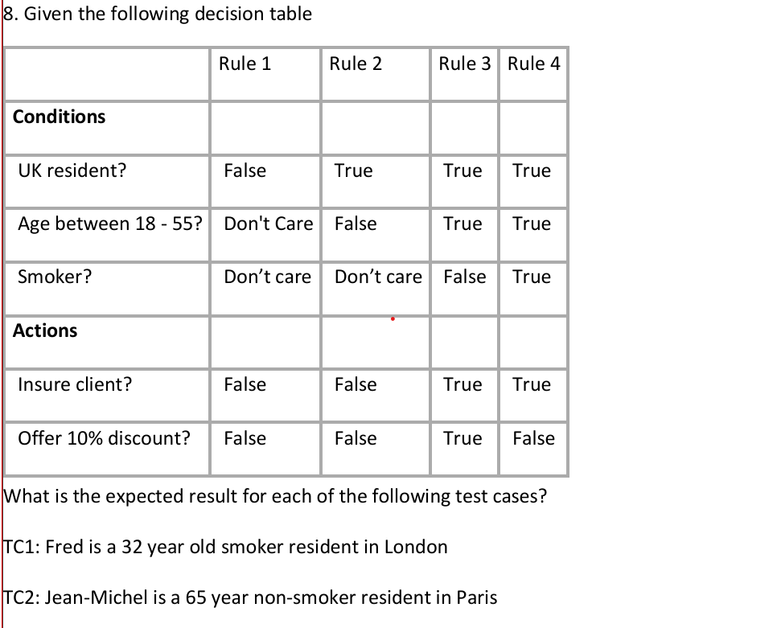

a) TC1 – Insure, 10% discount, TC2 – Insure, no discount

b) TC1 – Don’t insure, TC2 – Don’t insure

c) TC1 – Insure, no discount, TC2 – Don’t insure.

d) TC1 – Insure, no discount, TC2 – Insure with 10% discount

9. In a system designed to work out the tax to be paid: An employee has £4000 of salary tax free. The next £1500 is taxed at 10%. The next £28000 after that is taxed at 22%. Any further amount is taxed at 40%. To the nearest whole pound, which of these is a valid Boundary Value Analysis test case?

A. £28000

B. £33501.

C. £32001

D. £1500

10.

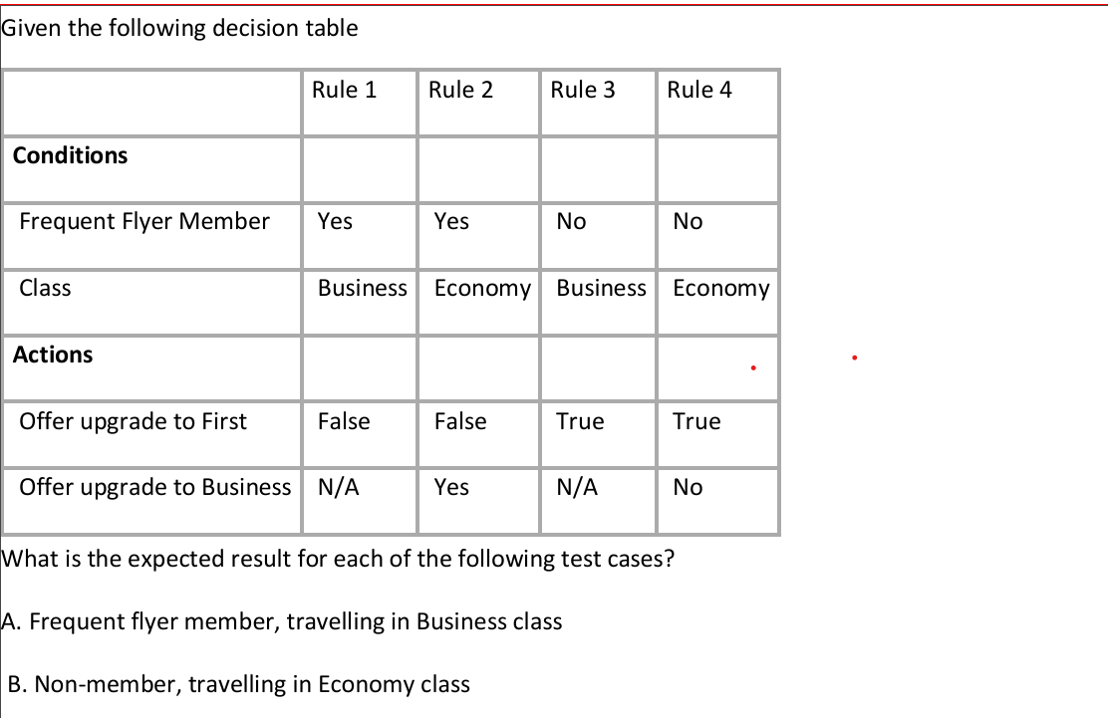

1. A – Don’t offer any upgrade,
2. B – Don’t offer any upgrade B. A – Don’t offer any upgrade, B – Offer upgrade to Business class
3. C. A – Offer upgrade to First, B – Don’t offer any upgrade.
4. D. A – Offer upgrade to First, B – Offer upgrade to Business class